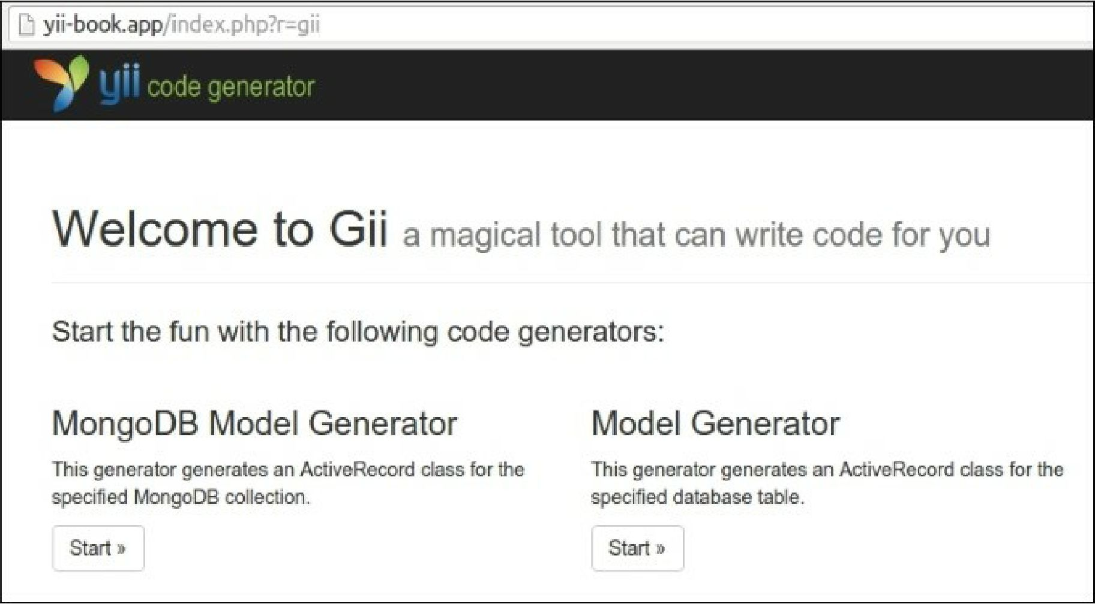

9. Start the new MongoDB Model Generator to generate the new model for your own collection: